Processing FUTA and SUTA for Third-Party Sick Pay

The purpose of this document is to outline the steps in processing FUTA and/or SUTA for third-party sick pay when the vendor is creating the W-2. You need to discuss with the third-party vendor, which employer taxes the client will be responsible for paying (FUTA, SUTA) and have the appropriate earning(s) code set up.
FICA/FMED taxes are discussed in Processing Third-Party Sick - W-2 Issued by Vendor. If the W-2 is issued by ProBusiness, see Processing Third-Party Sick - W-2 Issued by ADP.
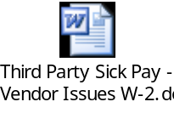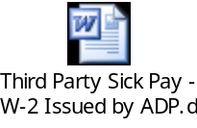
Steps:
 | Activity Description
1 | Find out from the third-party vendor which taxes need to be paid by employer.
2 | If an earnings code does not exist, complete the Earnings Request Form and Deduction Request Form for an offsetting deduction. This earnings code should be taxable for only FUTA and/or SUTA. Forward the completed forms to your account manager.  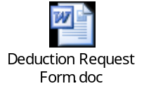
3 | Set up a third-party sick pay earnings code with an offsetting deduction. This earnings code should be taxable for only FUTA and/or SUTA.

4 | The third-party vendor should provide you with a statement which details out what was paid to the employee and which taxes were withheld. You will key manual checks for each employee listed on the statement. Third-party sick earnings can only be keyed in a manual check. It should not be keyed onto a worksheet or in check pro check.  - Go to Paydata → Manual/Void Checks → Create → Manual Checks  - Select the employee, not the Third-Party Sick Pay Recap employee  - Go to Earning Code field and type in 3 digit third-party sick earning code. (Or press F8 to view all codes and make selection.). Make sure that you select the earnings code that is only taxable for FUTA and/or SUTA.  - Type in Amount of sick pay earnings  - Click “OK” once completed  - Enter net amount of check when prompted to do so and click “OK”  - Click “OK” to save check  Note: Do not key in the offsetting deduction. The system will post the offsetting deduction when the check is processed.  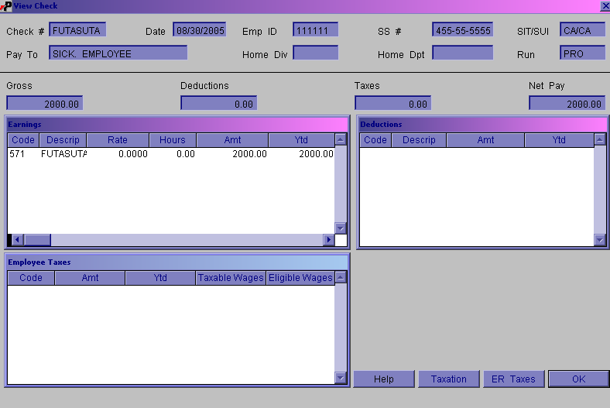
5 | Send up manual checks with a regularly scheduled payroll or with a special payroll. If you are sending the manual checks with a special payroll, coordinate the scheduling of the payroll with your account manager.
6 | Once the manual check has been processed with a payroll, you will see the following:  - Employer taxes that will be deposited by ADP  - No employee taxes  - Offsetting deduction that creates a zero net check  

